## **User Guide**

1. On accessing the application, Following is the homepage (PSB)

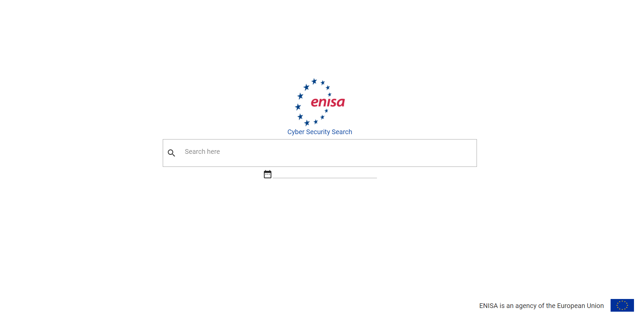

**B**

**A**

**A** : Enter search keyword e.g. Phishing

**B:** Enter Date Time Range to perform search for specific range. Please see below

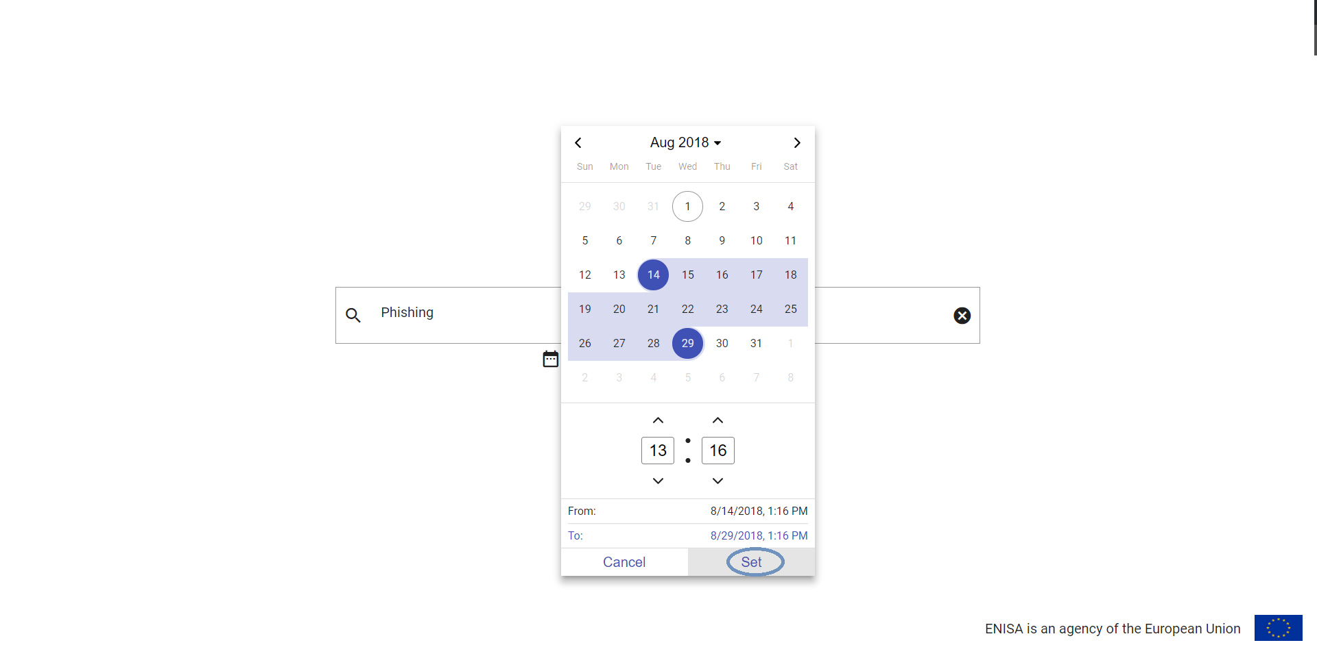

1. On pressing ‘Enter’ on search bar, It shows the results for the keyword and date filer (PSB)

**H**

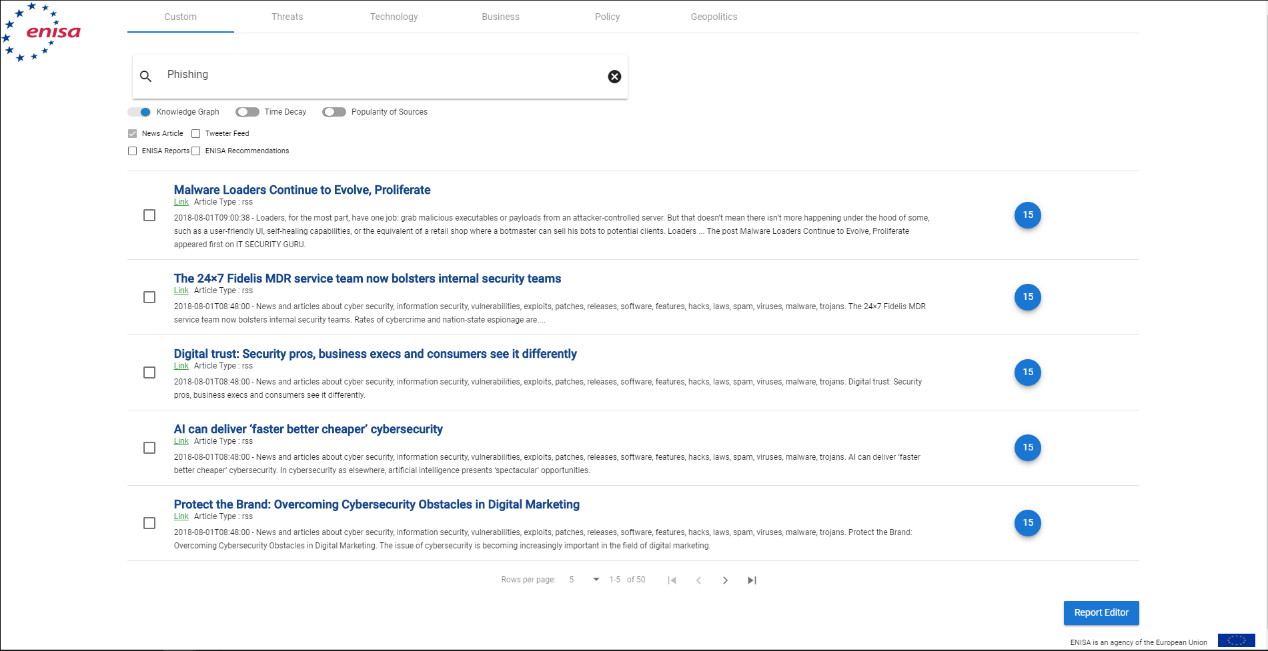

**G**

**E**

**C**

**F**

**D**

**C:** Tabs for different search key words

**D:** Search Criteria, you can toggle the toggle bars or check/uncheck the checkboxes and then press enter in a search box.

**E:** You can check/uncheck the results to create a report on it by pressing ‘Report Editor’ button**.**

**F:** Pagination of the data table. You can change the number of records displayed in this table using this. It shows displayed records and total records being fetched.

**G:** Report Editor Button, to Create a report on the selected articles.

**H:** Click on ENISA logo to move back to home page anytime

1. After selecting the articles, from different tabs, you can press Report Editor Button. It will show you following screen.

**I**

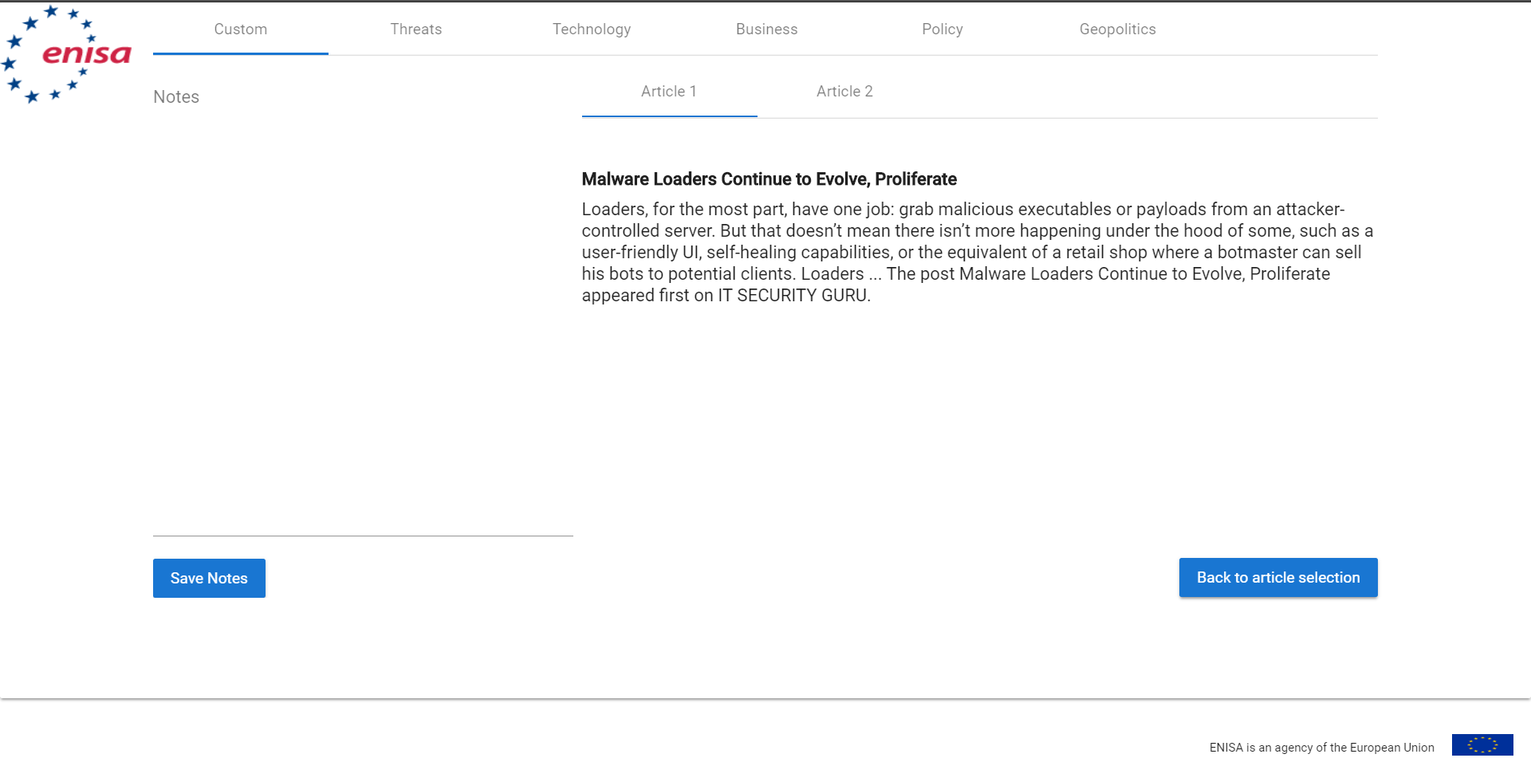

**N**

**M**

**L**

**K**

**J**

**I :** Go to Home Page

**J:** Input Area to add Notes for the report

**K:** Save the note (Download the notes)

**L:** Button for Back to Article Selection Screen

**M:** Articles being selected for current Tab ( in the image, it is Custom tab)

**N:** Shows all tabs and their selected articles